TELEWEST
FtpMover
Detailed Design Document
Author: Kaliven lee
Version: 1.2
Date: 2005-02-04

Contents
1 Introduction 5
1.1 Purpose 5
1.2 Scope 5
1.3 Definitions, Acronyms, and Abbreviations 5
1.4 References 5
1.5 Overview 5
2 Architecture 7
2.1 Architectural Goals and Constraints 7
2.2 Use-Case View 7
2.2.1 Use-Case Stories 7
2.2.2 Extension Use-Case 8
2.3 System Logical Structure 8
2.4 Deployment View 9
2.5 Error Handling and Fail-Over [optional] 9
2.6 Issues and Considerations 9
3 System Design/Change Summary 11
4 Static Class View 12
5 Tasks/Processes Function and Relation 14
5.1 Class FtpMover 14
5.2 Class FtpConnMgr and CFtpConnection 14
5.3 Class FtpMoverScaner 14
6 System Sequence View 15
6.1 Sequence Diagram 15
6.2 Program Flow Chart 17
7 Configuration 18
8 Directory (Folder) & File Structure 19
9 Interface Specification 20
10 Data Dictionary 21
10.1 Task 21
10.2 Work Queue 21

Revision History
Version | Revise Date | Owner | Notes
1.0 | 2005-1-27 | Kaliven lee | - Document draft
1.1 | 2005-2-4 | Kaliven lee | - Add state change diagram  - Add and change some configuration  - Add new consideration
1.2 | 2005-2-24 | Kaliven lee | - Add multiple destine server set  - Use XML as configure file

Introduction

Purpose
The module OSS (Operation Support System) of project TELEWEST will write its runtime report to a XML file. And this report file needs o be sent to specified TELEWEST server by FTP protocol. TELEWEST application will read the file to get the report information. And many other projects also have such similar requirement of moving files from one machine to another machine. So FtpMover is also a share module for future projects.

Scope
FtpMover guards the specified directory timely. If it found any files in this directory, it sent those files to the specified FTP server. Multiple files will be sent one by one.
The Ftp server is maintained by server side and can be any third standard Ftp server following RFC 959.
FtpMover only guarantees the transfer process. It does not exam the content of the files. How to build and parse the files is an upper protocol between the OSS and TELEWEST application.

Definitions, Acronyms, and Abbreviations
Name: Description.
OSS Operation Support System
FTP File Transfer Protocol

References
[R01] Reference 01

Overview
1. FtpMover is a timer which will scan the specified directory timely. If a file is found here, a new transfer task will be opened and pushed into the work queue.
2. FtpMover is a standard ftp client following RFC 959 which guarantees the transfer between the client and server. It picked up a task from work queue and then did the task circularly until no task in the work queue.
3. Because the size of report file is small, we process the tasks one by one in this project. However, considering the further implement, FtpMover should be able to process multiple tasks at same time when facing huge-size file transfer tasks.
4. FtpMover should be packed as SeaChange standard service for the sake of the stability.And so that user can use manutil to monitor the FtpMover service.

Architecture

Architectural Goals and Constraints
- This module will release with TELEWEST before 2005-2-24. So base function will be implement in this phase. Further functions mentioned in chapter will be added in the next version.
- This module should be packed as SeaChange service according to the requirement of TELEWEST. It can be run steadily under the framework of SeaChange Service. Framework of SeaChange Service also provides a SNMP monitor function (manutil) and Alarm system guard function.
- Because the report files are usually small, so these files can be transferred one by one. But we properly will face huge size file in the future applying. So FtpMover have a switch so that it can transfer multiple files at same time.
- FtpMover will maintain the whole life circle of temporary file. Move the File from guard directory to temp directory. Transfer it to server. And delete it from temporary directory.
- After finished development, this module should be released as install shield package. So that customer and QA can easily use this service.

Use-Case View
This section lists use cases or scenarios from the use-case model if they represent some significant, central functionality of the final system, or if they have a large architectural coverage—they exercise many architectural elements or if they stress or illustrate a specific, delicate point of the architecture.

Use-Case Stories
Single File Transfer Successful
Primary Actor: Actor
Preconditions: Server and FtpMover are in same subnet. Tcp/Ip is installed in each OS.
Success Guarantee: Net is ok. And server is set correctly
No. | Action | System Response
1 | Copy a file into specified directory of FtpMover | The file is sent to destine server. And original file is deleted
Multiple File Transfer Successful
Primary Actor: Actor
Preconditions: Server and FtpMover are in same subnet. Tcp/Ip is installed in each OS.
Success Guarantee: Net is ok. And server is set correctly
No. | Action | System Response
2 | Copy multiple files into specified directory of FtpMover | The file is sent to destine server one by one. And original file is deleted

Extension Use-Case
Net break
Primary Actor: Actor
Preconditions: Net is break
No. | Action | System Response
3 | Copy files into specified directory of FtpMover | The files are moved into temporary directory. And if the net is reconnected, the file is sent to the server.
FtpMover restart with some files left in temporary directory
Primary Actor: Actor
Preconditions: Some files is left in temporary directory
No. | Action | System Response
3 | Copy files into specified temporary directory and restart FtpMover | The files are sent to destination server. And then be delete from temporary directory.

System Logical Structure
Figure 1 describes the modules of the FtpMover. File Scanner scans the specified directory. If any file in, get the information of the file and push a task into work queue. And then move the file to the temporary directory. FtpConnMgr get the task from work queue timely. If found any task, it create a FtpConn to transfer the file. And under the retirement of the TELEWEST, only one FtpConn is allowed to run. If multiple FtpConns are allowed to run, multiple files can be transferred at same time. After finished the transfer, FtpConn will drop the task from the work queue FtpConnMgr will delete the file from the temporary directory.
File Scanner
FtpConnMgr
FtpConnn
Get file info& move file
Push
Pop
Read File
Create
Transfer File
Work Queue
Figure 1 FtpMover decomposition

Deployment View
The FtpMover transfer files by FTP protocol. So the machine of FtpMover run and the Ftp Server should be in the same subnet. And TCP/IP

Error Handling and Fail-Over [optional]
- Basic error handling is writing the error message to the log file.
- Main control loop will guard the thread it created if the important thread blocked. If it is, FtpMover will exit the main loop. And Srvshell will restart the service at once. So that FtpMover can rework all right.
- If net break, FtpCon will exit and reset states of the task to unprocessed in the work queue. FtpConnMgr will start a FtpConn instance to try to send the file again until the net is all right.
- Temporary file directory is set to buffer the files that need to be transferred. If net break, and then network resume, FtpMover will try to move the files again. If the OSS had build a new report-file with the same name, FtpMover will cover the old file with the new file, and sent the new file to server side.

Issues and Considerations
- If multiple directories need be monitor and file need to be sent to multiple different servers. To launch multiple instances of FtpMover is a resource cost solution. We can write multiple directories and multiple destine server to a XML file as configuration. FtpMover read the file and do the same job. This target should be accomplished in this version of FtpMover implement.
- Currently we have an implement of Ftp Client which encapsulates class CFtpConnection of MFC. It is not a very good implement of FTP especially when facing huge file transfer. If better implement is done, FtpMover should replace it with new Ftp implement.
- Elements’ status in work queue:
Task is the elements of the work queue. It owns an attribute “status” to describe the current status of the task. This attribute will be more useful in the future multiple-transfer FtpMover and error handling. And the Program State Diagram describes the state change of the FtpMover.
- Temporary File Directory:
Server side always wants to fetch the latest status of the OSS. So if there is a same name file in the Temporary File Directory, FtpMover will only cover the file and do not add a new task to work queue.
- When transfer the huge size file and a same name file is wrote into the guard directory, according to the logic of FtpScanner , FtpScanner will try to cover the old file. But if the old file is opened to transfer. The process of cover will be failed. Perhaps to rename the file is a solution.
- FtpConnMgr is a pool of FtpConn. It Will initialize one or several connections. And if any task comes, it will dispatch an idle connections to transfer the file.
- When FtpConnMgr scanned a finished task, it will remove it from the work queue and delete the temporary file.
- Scanner:
A scanner means FtpMover will guard a directory and send the file in the directory to several Ftp servers. FtpMover can own several scanners so that it can guard multiple directories and send the file to multiple servers.

System Design/Change Summary
Figure 2 describe the relationship between the FtpMover and it context. OSS and Telewest application are upper layer applications. They will write and read the XML file to guarantee the report content. While the FtpMover and Ftp server will keep the transfer safe and successful.
FtpMover
OSS
Ftp Server
Network
Telewest application
Figure 2 FtpMover Overview
Ftp server can be any standard third Ftp server side implement, such as Microsoft ftp server in windows 2000 server. FtpMover move files from its side to Ftp Server accord in standard FTP protocol.

Static Class View
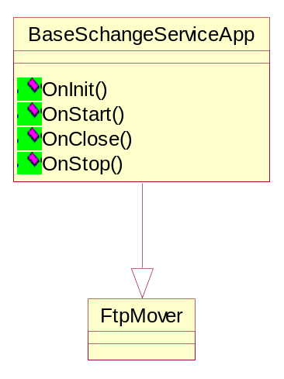
Figure 3 Class FtpMover
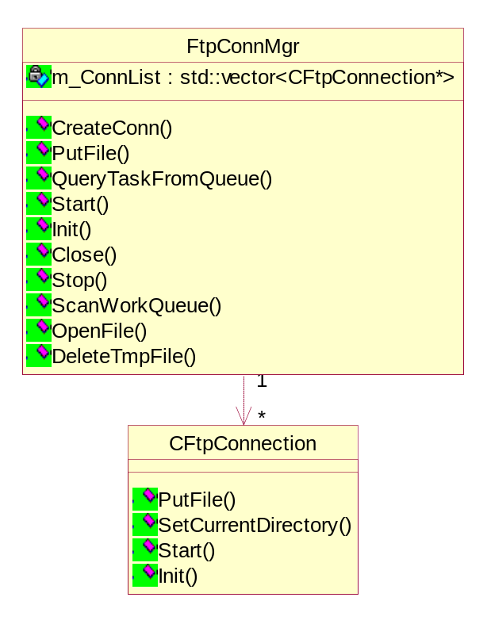
Figure 4 Class FtpConnMgr and CFtpConnection
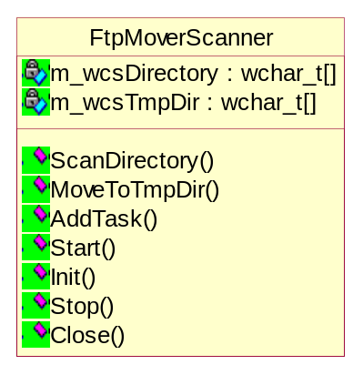
Figure 5 FtpMoverScaner

Tasks/Processes Function and Relation

Class FtpMover
FtpMover is hermit from BaseSchangeServiceApplication so that SeaChange Service features can be support.

Class FtpConnMgr
FtpConnMgr is a singleton. It is a pool of FtpConn and initialize one or several connections when it start. It scans the Work queue timely and dispatched the task to each connection to transfer. And if any task come, it will dispatch an idle connections to transfer the file.
When FtpConnMgr scanned a finished task, it will remove it from the work queue and delete the temporary file
There is only one instance of FtpConnMgr. It manages the multiple instances of FtpConn. But in this phase, only one FtpConn is allowed.

Class FtpConn
FtpConn encapsulate a Ftp implement of MFC CFtpConnection. It transfers the specified file by FtpConnMgr to configured server side. And it does not keep the connections when idle.

Class FtpMoverScaner
FtpMoverScaner scans the guard directory. If any file is copied into the directory, it will move the file to temporary path. And then add a task to work queue. If there is a duplicate transfer task in the work queue and its state is not processing, FtpMoverScaner do not add the task and cover the old file. And if its state is processing,(the file is open to transfer) FtpMoverScanner will add a time stamp at the end of file name and add a new transfer task into work queue.

System Sequence View
This section explains the execution sequence or work flow of the system.

Sequence Diagram
Figure 6 describe the sequence of SeaChange Service work flow.
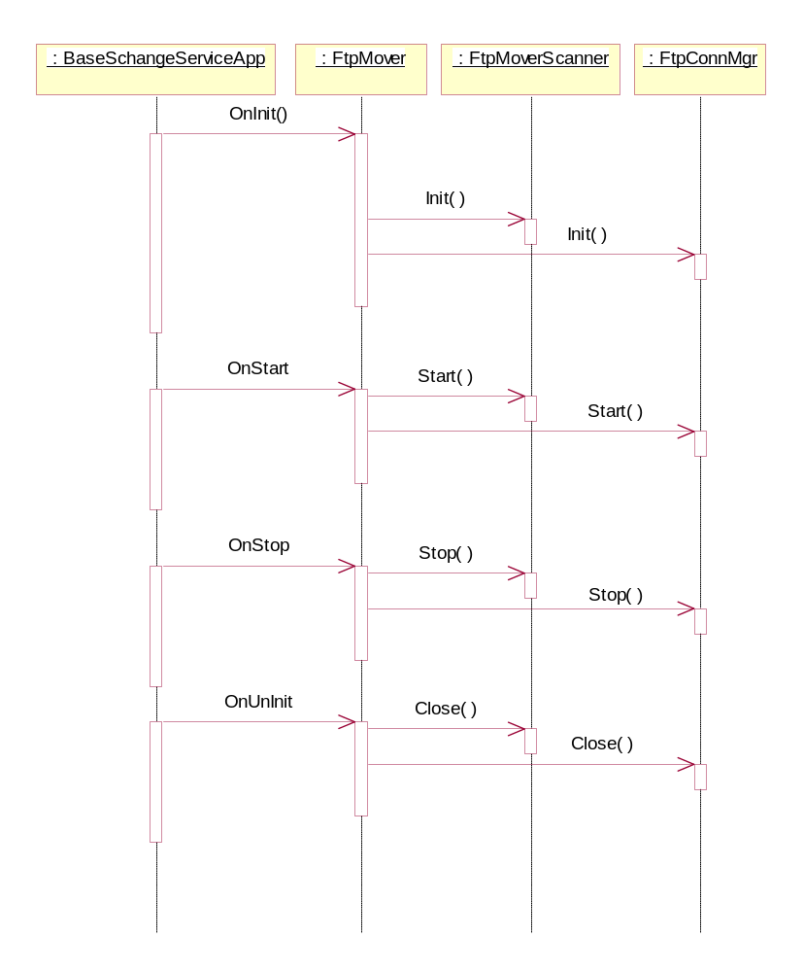
Figure 6 sequence of SeaChange Service work flow.
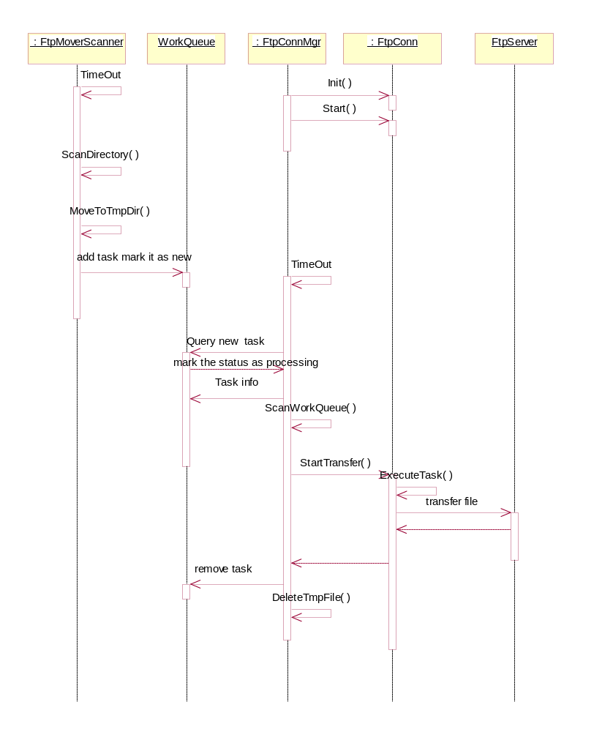
Figure 7 Sequence when FtpMover run

Program Flow Chart
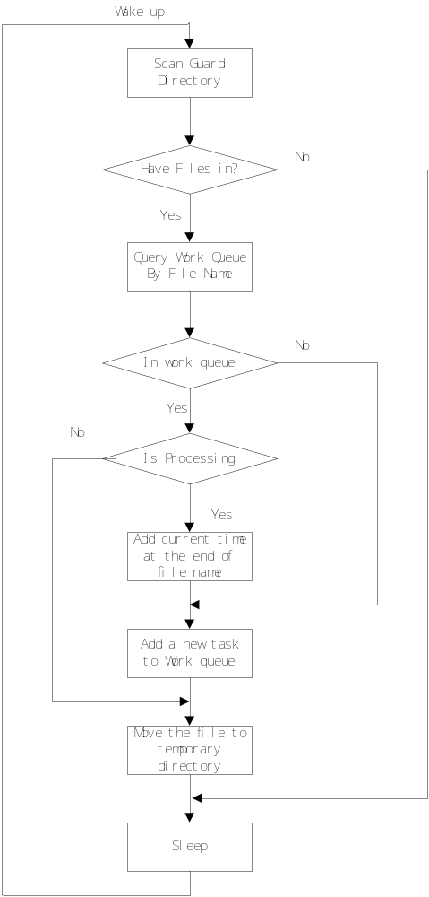.
Figure 8 workflow of FtpMoverScanner

State Change Diagram
In the FtpMover service, FtpConn and Task own an attribute of state. So that FtpConnMgr and FtpMoverScanner can process the object differently with different state. And Manutil monitor can be added in to watch the transfer states and help customer to trace the workstate of each transfer task in the next phase.

Task State change diagram
Figure 9 describe the task states change diagram. When the Task is created, its state is set to ‘Ready’ to show that the task can be sent by idle FtpConn. When FtpConnMgr found a idle connection, it will set the state of the task to processing to lock the task. So that other connection will not do the job again. And if FtpConn transfer the file ok, it will set the state to Finished. When FtpConnMgr scanned a ‘Finished’ task it will remove the task and delete the temp file. If processing the task failed,set the state to Failed. It shows that the task should be transferred again. When FtpConnMgr scaned a ‘Failed’ task, it will set the state to Ready and then try to retransfer the file.
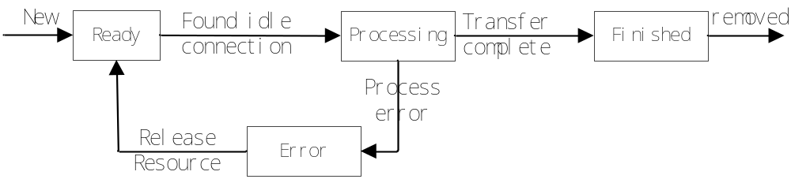
Figure 9 Task states change diagram

FtpConn state change diagram
Figuare 10 describe the FtpConn state change diagram. When FtpConn is created by FtpConnMgr, its state is set to be ‘Normal’. If FtpConn receive a request to send a file, it try to connect to destine ftp server. If failed, set it state to failed. And if success,it set its state to Ready. Then,FtpConn try to open the local file to read and remote file to write . if Failed ,set state to be ‘Failed’. If success, set it states to ‘Transferring’ and then start to transfer the file. If transfer failed, set the state to ‘Failed’. If Success, set its state to transferred. If FtpConnMgr scanned a FtpConn with state ‘failed’ and Transferred, it will release the resource of FtpConn and reset it as normal.
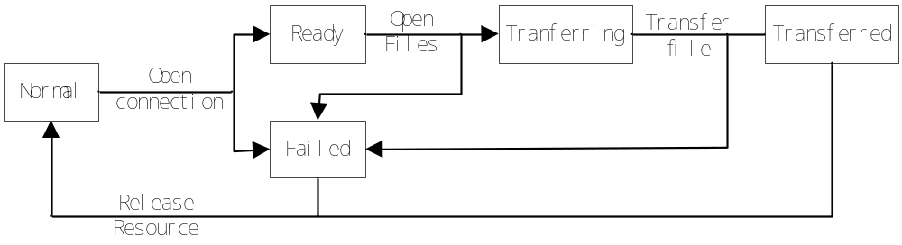
Figure 10 FtpConn state change diagram

Configuration
DBSync’s normal configuration is set in registry. And extensional configurations are wrote in XML file.

Configuration in registry:
HKEY_LOCAL_MACHINE\SOFTWARE\SEACHANGE\ITV\CURRENTVERSION\SERVICES\FtpMover\
Configuration | Description | Default Value
ScanDirInterval | The Interval to scan the directory that should be guard | 2000(ms)
ScanWQInterval | The Interval for FtpConnMgr to scan the directory that should be guard | 2000(ms)
MaxConnections | The max count of Ftp Connection | 1
ConfigFileName | The path and filename of Config XML file | C:\FtpMover\bin\FtpMover.xml

Configuration in XML file
<FtpMover>
<!-- here your can add multiple tasks for FtpMover to Guard.
but this function is left for next version of FtpMover.
-->
<Setting>
<ScanDirInterval>5000
</ScanDirInterval>
<ScanWQInterval>5000
</ScanWQDirInterval>
<MaxConnections>1
</MaxConnections>
</Setting>
<Scanner>
<GuardDirectory>c:\\guard\\
</GuardDirectory>
<TempDirectory>c:\\temp\\
</TempDirectory>
<!-- here your can add multiple FtpServers as your destine servers.
PLS make sure the ftp connetion between the localmachine and remote
Ftp server is ok.
-->
<FtpServer>
<Address>192.168.80.236
</Address>
<port>21
</port>
<user>am
</user>
<password>am
</password>
</FtpServer>
<FtpServer>
<Address>192.168.80.71
</Address>
<port>2121
</port>
<user>am
</user>
<password>am
</password>
</FtpServer>
</ Scanner >
</FtpMover>

Directory (Folder) & File Structure
This section describes directory and its structure in the system.

Interface Specification
The interface of the FtpMover abides the standard FTP protocol, which is described in RFC 959.

Data Dictionary

Task
typedef struct tag_TransferTask{
wchar_t wcsFileName[MAX_PATH];
wchar_t wcsRemoteFileName[MAX_PATH];
wchar_t wcsDestineServer[64];
wchar_t wcsUserName[32];
wchar_t wcsPassword[32];
DWORD dwPort;
TASKSTATE state;
}TRANSFERTASK;

TaskState
enum TASKSTATE{
Ready = 0,
Processing,
Finished,
Failed
};

Work Queue
Typedef Std::vector< TRANSFERTASK *> WORKQUEUE;

FtpConn states
#define FTPCONN_STATE_NOMORAL 0x0000
#define FTPCONN_STATE_TRANSFERRING 0x0001
#define FTPCONN_STATE_READY 0x0002
#define FTPCONN_STATE_TRANSFERRED 0x0003
#define FTPCONN_STATE_READFAILED 0x0004
#define FTPCONN_STATE_WRITEFAILED 0x0005

Pending question and other consideration
- If there are several directory need to be guard and sent to different server, One FtpMover service can not solute the problem. And there is only one service with the same name can be run in a machine. Run FtpMover with different name is a resource cost solution. So in the next phase, FtpMover need to handle it by oneself. The guard directories and destine servers can be configured by a XML file.FtpMover read the xml and get the configuration. And then process the files as its configuration.
- Facing big size file transferring, because of the accession of file, before the file finished writing, it can not be deleted or removed. So a timeout should be set to exam if the file can be deleted or moved. If the File access time is elapsed more than the time out it can be operated. And because of the deadline of telewest, this function will be added in the next version.

